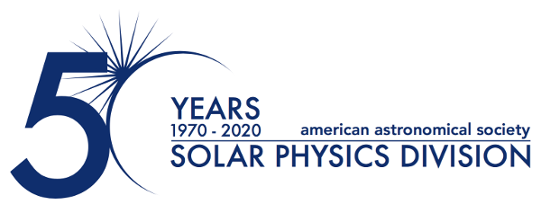

26 January 2022

AAS Solar Physics Division Announces 2022 Hale and Harvey Prizes

The Solar Physics Division (SPD) of the American Astronomical Society (AAS) is proud to announce the 2022 winners of its two most prestigious annual scientific prizes. Dr. Sami Solanki of the Max Planck Institute for Solar System Research (MPS) in Göttingen, Germany, is awarded the George Ellery Hale Prize for his foundational studies of solar magnetism, its impact on the Sun–Earth system, and magnetic fields of other stars. Dr. Adam Kowalski, who is joint faculty at University Colorado Boulder’s Department of Astrophysical and Planetary Sciences, the Laboratory for Atmospheric and Space Physics and National Science Foundation’s National Solar Observatory in Boulder, CO, is awarded the Karen Harvey Prize for his innovative research into stellar flares towards resolving long-standing problems relating to flares on both the Sun and other stars.

Dr. Sami Solanki has made many seminal contributions to the study of solar magnetism and its impact on the solar–terrestrial relationship over his career. His visionary and outstanding leadership and innovative instrument development have made him a pillar of the solar physics community. Dr. Solanki’s ground-breaking research has advanced understanding of the physical mechanisms that govern the structure and evolution of magnetic fields on the Sun and other stars and established reconstruction of the solar irradiance variability on timescales of days to millennia. In addition, Dr. Solanki led the balloon-borne Sunrise mission that demonstrated very high-resolution solar imaging from a flight platform, and the Polarimetric and Helioseismic Imager on the European Solar Orbiter mission that is currently in flight. He has also mentored generations of solar and space scientists into successful careers.

Dr. Adam Kowalski has made substantial contributions to understanding the response of lower stellar atmospheres to stellar flares using a combination of computer modeling, ground- and space-based observations, and theory. Dr. Kowalski’s research bridges the solar and stellar communities; this cross-cutting approach continues to yield important innovations on long-standing problems relating to flares on both the Sun and other stars. His early career research has advanced the understanding of continuum emission from flares, the interpretation of spectroscopic observations, and the timely subject of exoplanetary habitability.

The Hale Prize is awarded for outstanding contributions to solar astronomy over an extended period of time and is presented in memory of George Ellery Hale (1868-1938). The Harvey Prize recognizes a significant contribution to the study of the Sun early in a person's professional career and honors the memory of Karen L. Harvey (1942-2002).

Contacts:
Dr. Michael S. Kirk
Press Officer, AAS Solar Physics Division
NASA Goddard Space Flight Center, ASTRA LLC.
+1 301-614-7045
michael.s.kirk@nasa.gov, mkirk@astraspace.net

Dr. Susanna Kohler
Communications Manager and Press Officer, American Astronomical Society
+1 202-328-2010 x127
susanna.kohler@aas.org

The purpose of the AAS Solar Physics Division (SPD) is the advancement of the study of the Sun and the coordination of such research with other branches of science. These prizes will be presented at SPD’s 53rd meeting, a Triennial Earth-Sun Summit (TESS) joint meeting of the Space Physics and Aeronomy Section of the American Geophysical Union and the AAS Solar Physics Division, and will be held in Bellevue/Seattle, Washington, 8-12 August 2022. Since its founding, the SPD holds annual scientific meetings, awards several prizes, and supports students in various ways.

The American Astronomical Society (AAS), established in 1899, is a major international organization of professional astronomers, astronomy educators, and amateur astronomers. The mission of the AAS is to enhance and share humanity’s scientific understanding of the universe as a diverse and inclusive astronomical community.

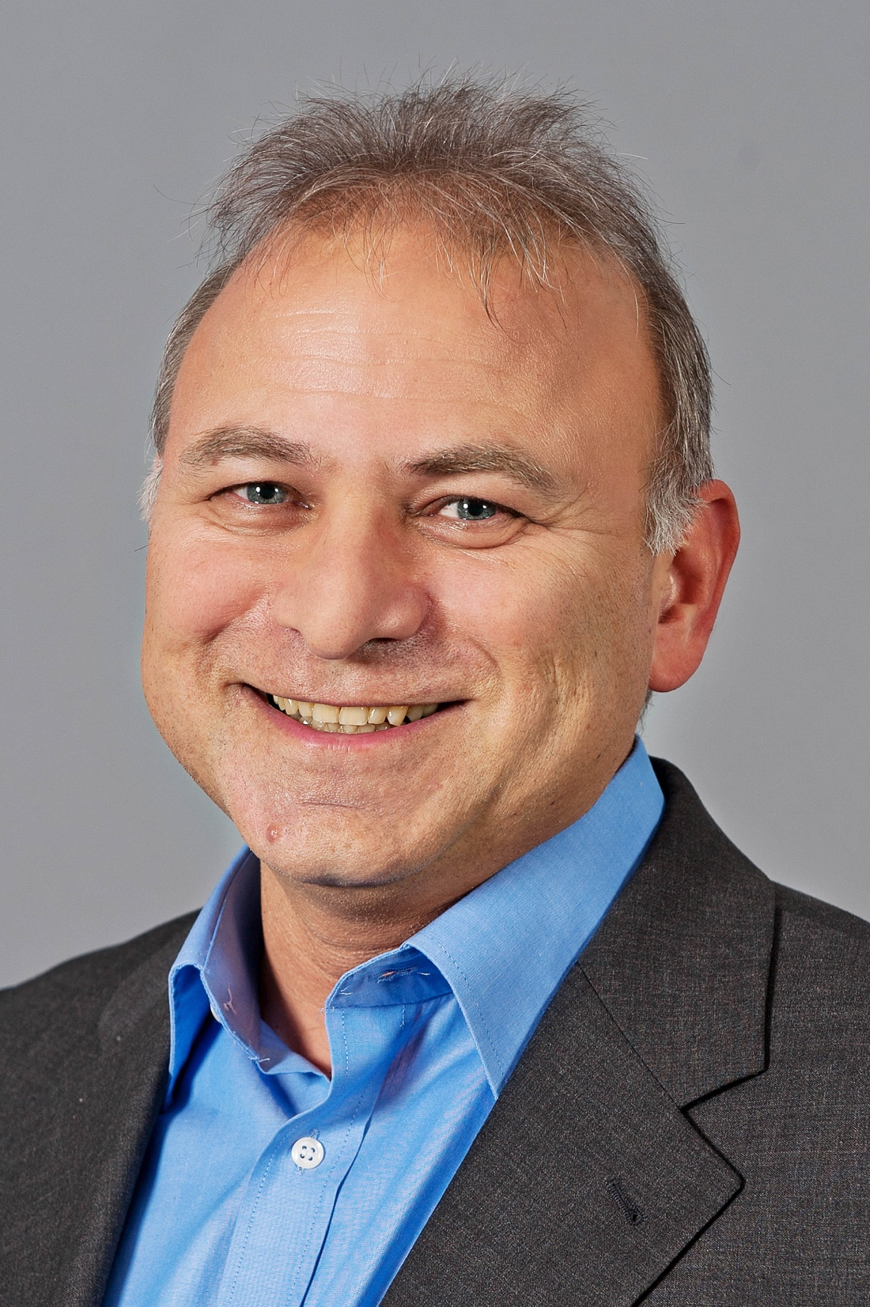
Dr. Sami Solanki of the Max Planck Institute for Solar System Research in Göttingen, Germany, is awarded the 2022 George Ellery Hale Prize.

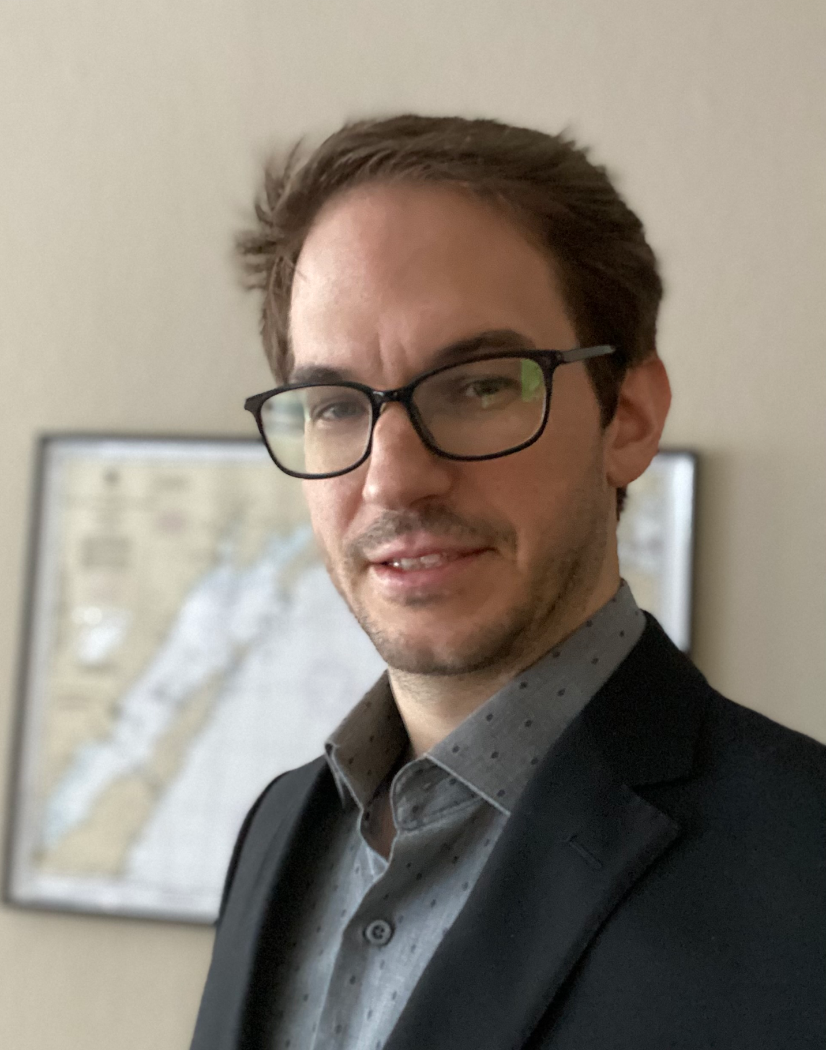
Dr. Adam Kowalski of the University Colorado Boulder’s Laboratory for Atmospheric and Space Physics and National Science Foundation’s National Solar Observatory in Boulder, CO, is awarded the 2022 Karen Harvey Prize.

