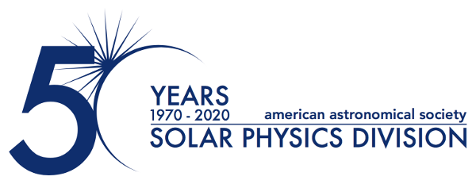

Naval Research Laboratory's Dr. Judith Lean Awarded the Prestigious 2024 George Ellery Hale Prize by the American Astronomical Society Solar Physics Division

February 26, 2024

The American Astronomical Society’s Solar Physics Division (AAS SPD) is proud to announce Dr. Judith Lean as the recipient of the esteemed 2024 George Ellery Hale Prize. Following a 30 year-career at the Naval Research Laboratory (NRL) she now works part-time at the Laboratory for Atmosphere and Space Physics (LASP). This honorary award is presented annually to a scientist who has made outstanding contributions to the field of solar astronomy over an extended period.

Dr. Lean is recognized for her foundational studies in solar irradiance variability and its impact on the Earth’s atmosphere and climate, on time scales from days to centuries. Her groundbreaking work has led to the development of the NRL suite of solar irradiance variability models, which are based extensively on solar observations. These models have gained wide acceptance across various communities and have been adopted by NOAA’s National Center for Environmental Information (NCEI) to produce the operational Solar Irradiance Climate Data Record, for use by the Earth science and climate communities, including the Intergovernmental Panel on Climate Change (IPCC).

Beyond her contributions to solar physics, Dr. Lean has played a pivotal role in studying natural solar influences on Earth’s upper atmosphere, stratosphere and climate. Her work crucially differentiates the solar-driven effects from the more dominant anthropogenic influences at the Earth’s surface, contributing significantly to the broader understanding of climate change and ozone layer depletion and recovery.

Dr. Lean's distinguished career is marked by her unique position of serving on both Earth Science and Heliophysics Decadal Survey Committees. Her multidisciplinary contributions have previously earned her membership in the National Academy of Sciences and the American Philosophical Society, and recognition as a lead author of the IPCC report for which, in 2007, she was a co-recipient of the Nobel Peace Prize alongside Vice President Albert (Al) Gore Jr.

The SPD honors Dr. Lean's exceptional dedication and contributions to the field of solar astronomy and solar-terrestrial science. Her work both advances our understanding of solar phenomena and plays a crucial role in shaping our response to global climate challenges.

About the George Ellery Hale Prize:
Established in memory of George Ellery Hale, the Prize is awarded by the SPD to a scientist for outstanding contributions to solar astronomy. The Prize Committee evaluates candidates based on the impact of their research in solar physics, general astronomy, geophysics, mathematics, and physics. The 2024 Hale Prize will be presented at SPD’s 54th meeting, a Triennial Earth-Sun Summit (TESS) joint meeting of the Space Physics and Aeronomy Section of the American Geophysical Union and the AAS SPD, which will be held in Dallas, Texas, 7-12 April 2024.

For more information, please contact:

Dr. Michael S. Kirk
Press Officer, AAS Solar Physics Division
NASA Goddard Space Flight Center
+1 301-614-7045
michael.s.kirk@nasa.gov

Dr. Susanna Kohler
Communications Manager and Press Officer, American Astronomical Society
+1 202-328-2010 x127
susanna.kohler@aas.org

The purpose of the AAS Solar Physics Division (SPD) is the advancement of the study of the Sun and the coordination of such research with other branches of science. Since its founding, the SPD holds annual scientific meetings, awards several prizes, and supports students in studying the Sun and heliosphere.

The American Astronomical Society (AAS), established in 1899, is a major international organization of professional astronomers, astronomy educators, and amateur astronomers. The mission of the AAS is to enhance and share humanity’s scientific understanding of the universe as a diverse and inclusive astronomical community.

