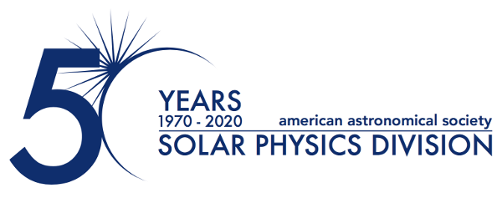

University of Arizona’s Prof. Kristopher Klein Awarded the Prestigious 2024 Karen Harvey Prize

February 26, 2024

The American Astronomical Society's Solar Physics Division (AAS SPD) is proud to announce Prof. Kristopher Klein of the University of Arizona as the esteemed recipient of the 2024 Karen Harvey Prize. Established in May 2002, this prestigious award honors the memory of the late Karen Harvey by recognizing significant contributions in solar physics research made early in a professional career.

Prof. Klein, a distinguished member of the Department of Planetary Sciences and the Lunar and Planetary Laboratory at the University of Arizona, has been selected for his outstanding contributions to our understanding of space plasma turbulence. His innovative work, which includes in situ observations of the solar wind, novel data analysis methods, theoretical frameworks, and simulations, has provided groundbreaking insights into the kinetics of solar wind evolution and the nature of plasma turbulence dissipation.

The Harvey Prize acknowledges Prof. Klein's exceptional achievements, which are not limited to research alone. His leadership in the scientific community is exemplified by his recent appointment as Project Scientist for the Solar Wind Electrons Alphas and Protons (SWEAP) instrument aboard NASA's Parker Solar Probe. Additionally, his role as Deputy Principal Investigator of the upcoming NASA HelioSwarm mission highlights his influential presence in the field of solar physics.

The AAS SPD community is excited to honor Prof. Kristopher Klein for his significant and influential work. His contributions not only advance our understanding of solar phenomena but also inspire the next generation of solar physicists.

About the Karen Harvey Prize:
Established in honor of solar physicist Karen Harvey, the Karen Harvey Prize is awarded annually by the AAS SPD. It recognizes significant contributions to the field of solar physics by individuals in the early stages of their professional career, emphasizing both research excellence and potential. The 2024 Harvey Prize will be presented at SPD’s 54th meeting, a Triennial Earth-Sun Summit (TESS) joint meeting of the Space Physics and Aeronomy Section of the American Geophysical Union and the AAS SPD, which will be held in Dallas, Texas, 7-12 April 2024.

For more information, please contact:

Dr. Michael S. Kirk
Press Officer, AAS Solar Physics Division
NASA Goddard Space Flight Center
+1 301-614-7045
michael.s.kirk@nasa.gov

Dr. Susanna Kohler
Communications Manager and Press Officer, American Astronomical Society
+1 202-328-2010 x127
susanna.kohler@aas.org

The purpose of the AAS Solar Physics Division (SPD) is the advancement of the study of the Sun and the coordination of such research with other branches of science. Since its founding, the SPD holds annual scientific meetings, awards several prizes, and supports students in studying the Sun and heliosphere.

The American Astronomical Society (AAS), established in 1899, is a major international organization of professional astronomers, astronomy educators, and amateur astronomers. The mission of the AAS is to enhance and share humanity’s scientific understanding of the universe as a diverse and inclusive astronomical community.

