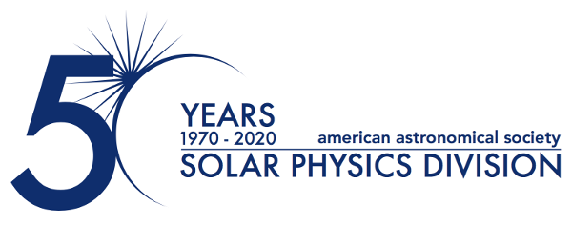
Dr. Holly R. Gilbert Awarded Inaugural Irene González Hernández Prize
January 15, 2025
The Solar Physics Division (SPD) of the American Astronomical Society (AAS) is pleased to announce that Dr. Holly R. Gilbert of the National Science Foundation’s National Center for Atmospheric Research (NCAR) has been selected as the recipient of the inaugural Irene González Hernández Prize. This prestigious award recognizes a mid-career scientist who has made significant and transformative contributions to the field of solar physics. The prize, established in April 2024 to honor the memory of Irene González Hernández, celebrates exceptional achievements in solar research, leadership, and community service.
Dr. Gilbert is recognized for her groundbreaking work on solar prominences, including their activation phases and connections to broader coronal dynamics. Her research has provided profound insights into the physical mechanisms driving solar activity, with far-reaching implications for understanding the Sun's impact on the heliosphere and space weather.
In addition to her scientific contributions, Dr. Gilbert has played a pivotal role in shaping the future of heliophysics through her leadership at both NASA and NCAR. Her visionary approach to setting scientific priorities has advanced research in solar physics, heliospheric physics, and space weather, promoting interdisciplinary collaboration and fostering the development of innovative instrumentation projects. Dr. Gilbert's commitment to diversity and inclusion has further strengthened the solar physics community through her support and mentorship of the next generation of scientists.
Dr. Gilbert’s contributions exemplify the spirit of this award, advancing our understanding of the Sun, catalyzing new approaches to key challenges in heliophysics, and setting a high standard for leadership and diversity that ensures solar physics remains a dynamic and inclusive scientific community. The AAS SPD community congratulates Dr. Gilbert on this recognition and celebrates her continuing contributions to the advancement of solar physics.
About the Irene González Hernández Prize:
The SPD Irene González Hernández Prize honors scientists in their mid-career stage — defined as between eleven and twenty years of cumulative professional experience following the completion of their terminal degree — for outstanding contributions that extend beyond the work recognized by other SPD awards. The award reflects the lasting impact of Irene González Hernández, a solar physicist remembered for her scientific rigor, dedication to the community, and passion for mentoring emerging researchers. The 2025 González Hernández Prize will be presented at SPD’s 56th meeting, held jointly with the AAS and the Laboratory Astrophysics Division during 8-12 June 2025 in Anchorage, Alaska.

For more information, please contact:

Dr. Michael S. Kirk
Press Officer, AAS Solar Physics Division
NASA Goddard Space Flight Center
+1 240-519-2065
michael.s.kirk@nasa.gov

Dr. Susanna Kohler
Communications Manager and Press Officer, American Astronomical Society
+1 202-328-2010 x127
susanna.kohler@aas.org

The purpose of the AAS Solar Physics Division (SPD) is the advancement of the study of the Sun and the coordination of such research with other branches of science. Since its founding, the SPD holds annual scientific meetings, awards several prizes, and supports students in studying the Sun and heliosphere.

The American Astronomical Society (AAS), established in 1899, is a major international organization of professional astronomers, astronomy educators, and amateur astronomers. The mission of the AAS is to enhance and share humanity’s scientific understanding of the universe as a diverse and inclusive astronomical community.

