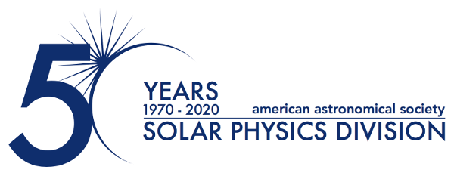
Dr. James Klimchuk Awarded 2025 George Ellery Hale Prize
January 15, 2025
The Solar Physics Division (SPD) of the American Astronomical Society (AAS) is proud to announce that Dr. James Klimchuk of NASA Goddard Space Flight Center has been selected as the recipient of the 2025 George Ellery Hale Prize. This esteemed award recognizes Dr. Klimchuk for his transformative scientific contributions to the understanding of the Sun's hot atmosphere, his dedication to fostering scientific discovery within the solar physics community, and his exemplary leadership in advancing the field of heliophysics.

Dr. Klimchuk’s groundbreaking work has profoundly shaped our understanding of the coronal heating problem — one of the most enduring questions in solar physics. Through an innovative blend of theory, modeling, and observations, Dr. Klimchuk has provided deep insights into the processes that heat the Sun's outer atmosphere to millions of degrees. His research has led to significant advancements in our understanding of the mechanisms that drive solar activity and influence space weather.

Beyond his scientific achievements, Dr. Klimchuk has made invaluable contributions to the solar physics community by developing tools that enable others to make scientific discoveries. His development of an easy-to-use hydrodynamics code has provided a critical resource for researchers worldwide, facilitating studies of solar plasma dynamics and energy transfer in the Sun’s atmosphere.

A champion of community-building and collaboration, Dr. Klimchuk has played a pivotal role in organizing key scientific gatherings, such as the long-running Solar Coronal Loops Workshop and the Triennial Earth-Sun Summit (TESS), which foster collaboration across the solar and space physics communities. His leadership and mentorship have also helped shape the next generation of solar physicists, promoting a collaborative research environment and leaving a lasting impact on the field.

"Dr. Klimchuk’s work exemplifies the spirit of the Hale Prize, recognizing not only his scientific excellence but also his profound influence on the broader solar physics community," said Dr. Nicholeen Viall, Chair of the Solar Physics Division. "Throughout his career, Dr. Klimchuk has left an indelible mark on solar physics through his pioneering research and dedication to mentorship and community-building. His legacy will continue to shape the field for years to come."
About the George Ellery Hale Prize:
Established in memory of George Ellery Hale, the Prize is awarded by the SPD to a scientist for outstanding contributions to solar astronomy. The Prize Committee evaluates candidates based on the impact of their research in solar physics, general astronomy, geophysics, mathematics, and physics. The 2025 Hale Prize will be presented at SPD’s 56th meeting, held jointly with the AAS and the Laboratory Astrophysics Division during 8-12 June 2025 in Anchorage, Alaska.

For more information, please contact:

Dr. Michael S. Kirk
Press Officer, AAS Solar Physics Division
NASA Goddard Space Flight Center
+1 301-614-7045
michael.s.kirk@nasa.gov

Dr. Susanna Kohler
Communications Manager and Press Officer, American Astronomical Society
+1 202-328-2010 x127
susanna.kohler@aas.org

The purpose of the AAS Solar Physics Division (SPD) is the advancement of the study of the Sun and the coordination of such research with other branches of science. Since its founding, the SPD holds annual scientific meetings, awards several prizes, and supports students in studying the Sun and heliosphere.

The American Astronomical Society (AAS), established in 1899, is a major international organization of professional astronomers, astronomy educators, and amateur astronomers. The mission of the AAS is to enhance and share humanity’s scientific understanding of the universe as a diverse and inclusive astronomical community.

