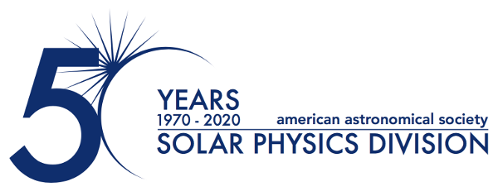

12 January 2021

AAS Solar Physics Division Announces 2021 Hale and Harvey Prizes

The Solar Physics Division (SPD) of the American Astronomical Society (AAS) is proud to announce the 2021 winners of its two most prestigious annual scientific prizes. Dr. Russell Howard of the United States Naval Research Laboratory (NRL) in Washington, DC, is awarded the George Ellery Hale Prize for his seminal work on the discovery, measurement, and understanding of coronal mass ejections (CMEs). Dr. Lucia Kleint of the University of Geneva, Switzerland, is awarded the Karen Harvey Prize for her substantial contributions to solar polarimetry and radiative transfer modeling, and exceptional leadership in next-generation solar instrumentation.

Dr. Howard has a rich legacy of influential contributions to the discovery, measurement, and physical understanding of CMEs and outstanding leadership in the development, deployment, and management of innovative space instrumentation to image the solar corona and inner heliosphere. Dr. Howard’s pioneering research has helped form the foundation of current heliophysics through the development of heliospheric imagers over the last 50 years. From the earliest days of CME observations with OSO-7, through the prolific SOHO LASCO coronagraphs, to the recently launched WISPR and SoloHI instruments on Parker Solar Probe and Solar Orbiter, Dr. Howard’s keen insight and strong leadership has illuminated the origin and effects of CMEs on space weather. In addition, his work on statistical properties of CMEs and on Earth-directed (halo) CMEs have been key to understanding their impacts on our planet’s upper atmosphere.

Dr. Kleint has made several significant contributions to the observation and understanding of solar flares and is currently leading a research group toward solving several important open questions on flares. Early in her career, she has already observed and modeled turbulent magnetic fields in the quiet Sun, led spectropolarimetric and spectroscopic observations and analysis of flares in the photosphere and chromosphere at an unprecedented high precision, and pioneered the application of machine learning techniques to solar flare data. Dr. Kleint coordinated the flight software team for the Spectrometer/Telescope for Imaging X-rays (STIX) currently flying on Solar Orbiter and led the German Solar Telescopes where she was responsible for a major redesign of the optical system and operations for the GREGOR telescope.

The Hale prize is awarded for outstanding contributions to solar astronomy over an extended period of time and is presented in memory of George Ellery Hale (1868-1938). The Harvey Prize recognizes a significant contribution to the study of the Sun early in a person's professional career and honors the memory of Karen L. Harvey (1942-2002).

Contacts:
Dr. Michael S. Kirk
Press Officer, AAS Solar Physics Division
NASA Goddard Space Flight Center, ASTRA LLC.
+1 301-614-7045
michael.s.kirk@nasa.gov, mkirk@astraspace.net

Dr. Rick Fienberg
Press Officer, American Astronomical Society
+1 202-328-2010
rick.fienberg@aas.org

The purpose of the AAS Solar Physics Division (SPD) is the advancement of the study of the Sun and the coordination of such research with other branches of science. The 52nd meeting of the SPD will be held in Bellevue/Seattle, Washington, 9-12 August 2021. Since its founding, the SPD holds annual scientific meetings, awards several prizes, and supports students in various ways.

The American Astronomical Society (AAS), established in 1899 and based in Washington, DC, is the major organization of professional astronomers in North America. The mission of the AAS is to enhance and share humanity’s scientific understanding of the universe.

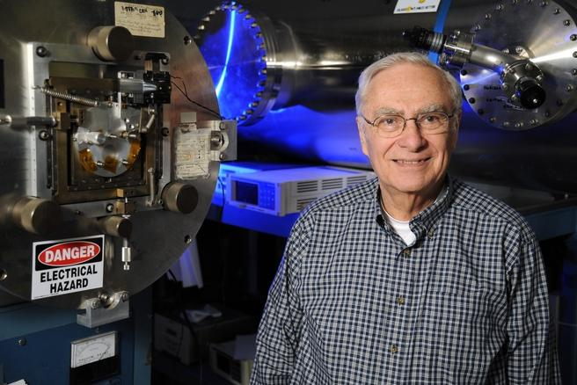

Dr. Russell Howard of the United States Naval Research Laboratory (NRL) in Washington D.C., is awarded the 2021 George Ellery Hale Prize.
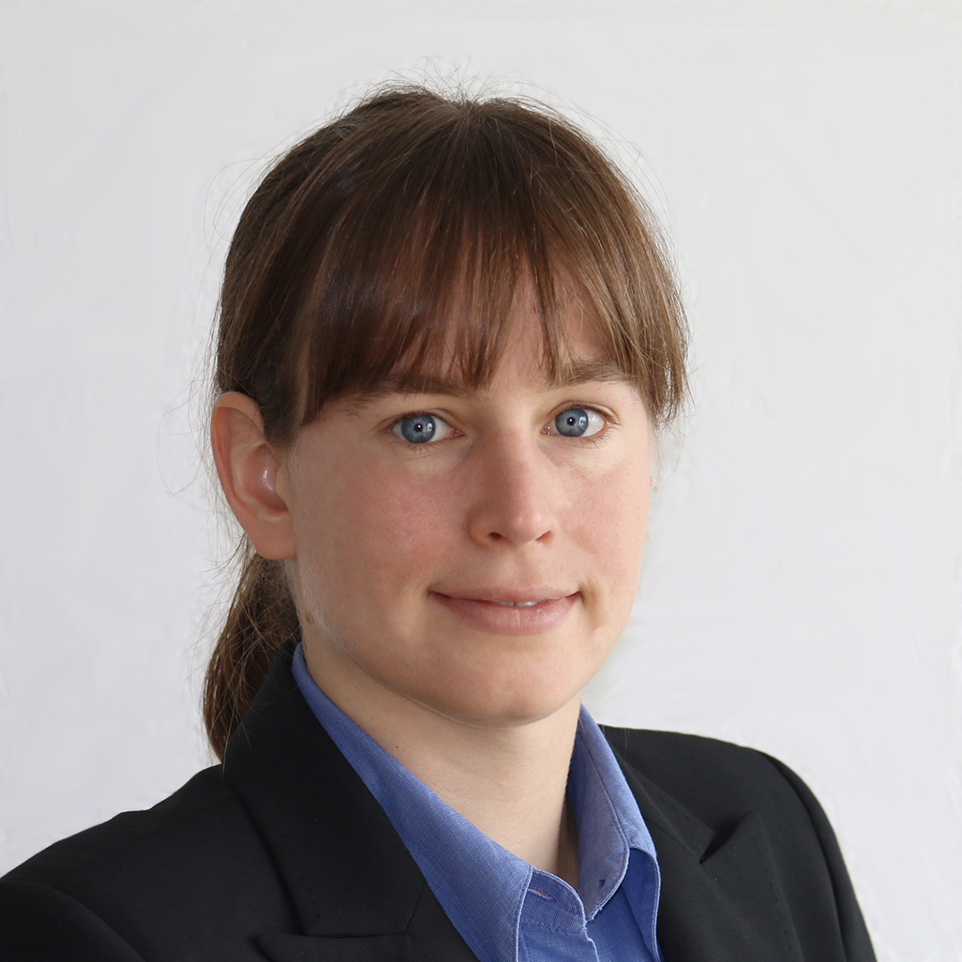
Dr. Lucia Kleint of the University of Geneva, Switzerland, is awarded the 2021 Karen Harvey Prize.

