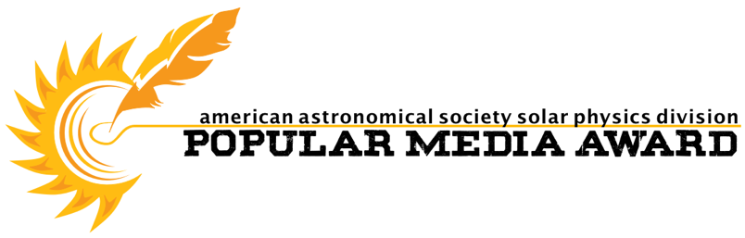
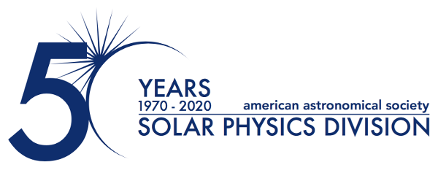

2022 May 24

AAS Solar Physics Division Announces 2022 Popular Media Awards

The AAS Solar Physics Division (SPD) is proud to announce the winners of the 2022 Popular Media Awards are Colin Stuart, Mara Johnson-Groh, and Joy Ng. Colin Stuart is awarded for his article “Solar Trouble: How Well Do We Know the Sun?,” published in the April 2021 edition of Sky & Telescope Magazine, where he describes the ongoing uncertainties in quantifying solar elemental abundances and the ramifications for understanding the Universe. Mara Johnson-Groh and Joy Ng are jointly recognized for their article and accompanying video entitled “NASA Enters the Solar Atmosphere for the First Time, Bringing New Discoveries,” published on 2021-12-14 on nasa.gov and YouTube, respectively, where they explain the revolutionary discoveries made by Parker Solar Probe as it passed through the coronal Alfvén surface for the first time.

The SPD Popular Media Awards are presented annually to authors of popular articles and new media about the Sun or the relationship between the Sun and Earth. More information about the annual award can be found on the SPD website and how to submit content for consideration for next year’s award.

Contact:

Dr. Michael S. Kirk
Press Officer, AAS Solar Physics Division
NASA Goddard Space Flight Center
+1 301-614-7045
michael.s.kirk@nasa.gov

